**Home Automation and Security Systems for Elderly People**

**(A THESIS REPORT)**

**Submitted by**

|  |  |  |
| --- | --- | --- |
| Member’s Name | MAKAUT Roll No. | MAKAUT Reg. No. |

|  |  |  |
| --- | --- | --- |
| Aritra Kumar Basu | 0615010010 | 151270110635 |
| Kushal Bhowmick | **0615010016** | **151270110641** |
| Prit Singh | **0615010023** | **151270110648** |
| Rishav Roy | **0615010025** | **151270110650** |
| Sagar Gupta | **0615010027** | **151270110652** |
| Trinanjana De | **0615010035** | **151270110660** |

Under the guidance of

**Mrs. Bansari Deb Majumder**

**Head of Department, EIE**

In partial fulfillment for the award of the degree of

**Bachelor of Technology**

**In**

**Electronics and Instrumentation Engineering**

**NARULA INSTITUTE OF TECHNOLOGY**

**81, Nilgunj Road, Agarpara, Kolkata 700109**

**June, 2019**

**CERTIFICATE OF APPROVAL**

This is to certify that Aritra Kumar Basu, Kushal Bhowmick , Prit Singh, Rishav Roy, Sagar Gupta, Trinanjana De of 2015-2019 have submitted this thesis report on “Home Automation and Security Systems for Elderly People” in partial fulfillment of the requirement for the Degree of Bachelor of Technology in Applied Electronics and Instrumentation Engineering of WBUT in the year 2019 under my supervision.

This report is ready for evaluation.

Bansari Deb Majumder Bansari Deb Majumder

(SUPERVISOR) (HEAD OF THE (EXTERNAL

DEPARTMENT) EXAMINER)

Date:21/05/2019

**ACKNOWLEDGEMENT**

We would like to express our gratitude to (Bansari Deb Majumder HOD of Electronics and Instrumentation Engineering), Narula Institute of Technology for her valuable guidance which helped us a lot in due course of the project work,

We would like to thank (Bansari Deb Majumder HOD Electronics and Instrumentation Engineering), Narula Institute of Technology who had given all the support for performing experiments in this regard.

Finally we would like to thank (Bansari Deb Majumder HOD of Electronics and Instrumentation Engineering), Narula Institute of Technology, who extended all the facilities of the department for the project work.

**Group member name Signature**

Aritra Kumar Basu

Kushal Bhowmick

Prit Singh

Rishav Roy

Sagar Gupta

Trinanjana De

**CONTENTS**

1. **Chapter 1 PAGE NO.**

1.1 Introduction 07

1.2 Motivation factor behind the project 08

1.2.1 Literature review 10

2. **Chapter 2**

2.1 Project overview 11

2.2 Project objective 15

2.3 Components/ Tools used 16

2.3.1 Specification 17

2.3.2 Functionality 19

**3. Chapter 3**

3.1 Flow chart 22

3.2Circuit Diagram 23

**4. Chapter 4**

4.1 Result Analysis 26

**5. Chapter 5**

5.1 Application and Future scope 35

**6. References** 37

**7. Annexure A** 38

**8. Annexure B** 45

**CONTENT OF TOPIC**

**TOPIC NAME PAGE NO.**

**AUTOMATION 12**

**DISADVANTAGES OF HOME AUTOMATION 14**

**LIGHT CONTROL SYSTEM 35**

**CONTENT OF FIGURES**

**FIG NO. PAGE NO.**

**2.1**Blynk 16

**2.2** 12 v D.C fan 19

**3.1** Flow Chart 22

**3.2** Circuit diagram 1 23

**3.3** Circuit diagram 2 24

**3.4** Circuit diagram 3 25

**4.1** Snapshot of graph 27

**4.2** Snapshot of reading 28

**4.3** Snapshot of blynk app 29

**4.4** Snapshot of button setting 30

**4.5** Snapshot of notification settings 31

**4.6** Snapshot of widgets 32

**4.7** Snapshot of notification received 33

**4.8** Snapshot of circuit 34

**4.9** Snapshot of arduino coding 35

**CONTENT OF FIGURES**

**FIG NO. PAGE NO.**

**5.1** NODEMcu 46

**5.2** Relay 47

**5.3**Arduino Mega 48

**5.4** PIR Sensor 49

**5.4** Gas Sensor 50

**5.5** Thermistor 51

**CHAPTER 1**

**INTRODUCTION**

The 21st century is standing at the edge of the transition of mere *Homo sapiens* into a semi-robotic species, where the thin line between reality and scientific fiction is about to be crossed and looking forward to a technological colossal and an illustrated future, our project is a reflection of the extreme engineering creativities that go a long way towards an easy and hassle-free life. The project aims to reduce human efforts and errors, making fully automated systems a luxury as well as a necessity.

Industrialization is the period of social and economic change that transforms a human group from an agrarian society into an industrial society, involving the extensive re-organization of an economy for the purpose of manufacturing. From the time being we humans have looked forward to utmost comfort and best of our health. This lead to the transformation of huge manual industries into machine made industries which resulted in the overall cost saving. New technologies and machines were discovered which stride to make our daily lives easy endeavor. The industrialization of the world changed the manner in which people lived and the way societies interacted in a variety of ways including quality of life, economic power and political repercussions.  The landscape of the world morphed from a primarily agrarian culture to mechanical.  The new industrialization required people to re-think the cultural norms and adapt to the new way of life as well.

Try to imagine what your life would be like without any machines working for you. Make a list of the machines in your household and on your person; you may arrive at a surprising number. Now imagine earlier generations during their childhood years. How did they move from place to place? How did they communicate? What foods did they eat? The industrial revolution was brought about with the sole purpose of making the human life burden free and less exhausting. Since then we have come a long way in benefiting ourselves with the luxury that machines and new technology have got to offer us. Many people around the world today enjoy the benefits of industrialization. With so much more energy flowing through human systems than ever before, many of us must do much less hard physical labor than earlier generations did. People today are able to feed more babies and bring them to adulthood.

**Motivation Factor Behind The Project**

With a rapid growth in industries since the Industrial Revolution, industrialization took a whole new form in the latter part of the 20th century continuing till the 21st century where we witnessed the emergence of easy-to-communicate, portable, light-weight devices like mobile phones and laptops. Now we are trying to take the luxury offered by these devices to the next level by introducing *automation*.

What is automation?

The dictionary defines automation as “the technique of making an apparatus, a process, or a system operate automatically.”

The ISA (Industry Standard Architecture) defines automation as "the creation and application of technology to monitor and control the production and delivery of products and services.” Using the definition of ISA, the automation profession includes “everyone involved in the creation and application of technology to monitor and control the production and delivery of products and services”; and the automation professional is “any individual involved in the creation and application of technology to monitor and control the production and delivery of products and services.”

Think about the cell phone and computer you use every day to do your job. Think about the car you drive to take to work. Think about the food you eat; water you drink; clothes you wear; and appliances you use to store, prepare, and clean them. Think about the television you watch, video games you play, or music system you listen to. Think about the buildings you visit. Think about any modern convenience or necessity. Just about anything you can think of is the result of complex processes. Without talented individuals to design, build, improve, and maintain these processes, these technological advances would never have occurred and future innovations would be impossible. Without automation professionals, our world and our future would be very different. Automation has been achieved by various means including mechanical, hydraulic, pneumatic, electrical, electronic devices and computers, usually in combination. Complicated systems, such as modern factories, airplanes and ships typically use all these combined techniques. The benefit of automation includes labor savings, savings in electricity costs, savings in material costs, and improvements to quality, accuracy, and precision.

Automation **crosses all functions** within industry from installation, integration, and maintenance to design, procurement, and management. Automation even reaches into the marketing and sales functions of these industries. Automation involves a very **broad range of technologies** including robotics and expert systems, telemetry and communications, electro-optics, Cyber security, process measurement and control, sensors, wireless applications, systems integration, test measurement, and many, many more.

Why do we need automation?

* **Reduce Worker Fatigue and Effort or Labor Intensive Operation:**

Typically, humans dislike banal, repetitive tasks. However, computer systems perform them without complaint. Tasks that lack variability provide a place for automated systems to shine, but this also holds true for systems utilizing advanced sensors and integration.

* **Prevent Products or Materials from Being Damaged or Destroyed:**

Humans make mistakes when they fatigue. Mistakes using tools mean damaging raw materials, components, assemblies, and end products.

* **Prevent Non-conforming Product from Shipping:**

 Automated systems will not violate the instruction set. Moreover, automated systems may employ inspection capabilities. Tune the system and allow the data to roll in without preference or bias.

* **Increase Efficiency:**

Automated systems allow for improvements that benefit from consistent execution. Perfect planning and training do not defend against the human touch.

* **Collect Better Data:**

Remove the accidental data entry or missed data point from logging. Make the method of collecting sensor and process data regulated.

* **Improve Metrics:**

 Sending reliable data directly to a database provides an ongoing resource. Leveraging data can provide these answers beyond a simple list of pass/fail statistics from the past.

* **Devise the Right Process Improvements:**

Automated systems now collect reliable data. The database provides a searchable forum. Equipped with copious amounts of reliable data, engineers make the most of this information.

* **Save Money:**

Simply, inventing in[**industrial automation**](https://duotechservices.com/industrial-automation) yields cost savings through making processes more regular and collecting data for making confident decisions.

**Literature Reviews**

Review 1:

This system has been designed to assist and provide support to elderly and disabled person at home. Google application has been used as voice recognition and process the voice input from the smart phone. The voice input has been captured by the android and will be send to the **NodeMCU**. *WIFI* module in **NodeMCU** receives the signal and process the input signal to control home appliances. The propose system intend to control electrical appliances with relatively user friendly interface and ease of installation.

Review 2:

The main attraction of any automated system is reducing human labor, effort, time and errors due to human negligence. With the development of modern technology, smart phones have become a necessity for every person on this planet. Applications are being developed on Android systems that are useful to us in various ways. Another upcoming technology is natural language processing which enables us to command and control things with our voice. Combining all of these, our paper presents a microcontroller based voice controlled home automation system using Smartphone’s. Such a system will enable users to have control over every appliance in his/her home with their voice. All that the user needs is an Android smart phones, which is present in almost everybody’s hand nowadays, and a control circuit.

Review 3:

This endeavor has limitations when it comes to the area coverage. It works in a limited radius as the **WIFI** module is used. To overcome this constrain of radius we have introduced a feasible solution in the **NodeMCU**. It works on an application that is supported by Android.

**CHAPTER 2**

**OVERVIEW OF THE PROJECT**

Home automation gives you access to control devices in your home from a mobile device anywhere in the world. The term may be used for isolated programmable devices, like thermostats and sprinkler systems, but home automation more accurately describes homes in which nearly everything — lights, appliances, electrical outlets, heating and cooling systems — are hooked up to a remotely controllable network. From a home security perspective, this also includes your alarm system, and all of the doors, windows, locks, smoke detectors, surveillance cameras and any other sensors that are linked to it.

The first and most obvious beneficiaries of this approach are “smart” devices and appliances that can be connected to a local area network, via Ethernet or Wi-Fi. However, electrical systems and even individual points, like light switches and electrical outlets, were also integrated into home automation networks, and businesses have even explored the potential of IP-based inventory tracking. Although the day is still far off when you’ll be able to use your mobile browser to track down a lost sock, home networks are capable of including an increasing number of devices and systems.

*Home automation is a step toward what is referred to as the “Internet of Things,” in which everything has an assigned IP address, and can be monitored and accessed remotely.*

In today’s world Automatic systems are being preferred over manual systems. With the rapid increase in the number of users of internet over the past few years, Internet has become an integrated part of our life and **IoT**is the latest and emerging internet technology**. Internet of Things** is a growing network of everyday object-from industrial machine to consumer goods that can share information and complete tasks while you are busy with other activities.

What is Internet of Things?

The internet of things, or IoT, is a system of interrelated computing devices, mechanical and digital machines, objects, animals or people that are provided with unique identifiers ( UIDs) and the ability to transfer data over a network without requiring human-to-human or human-to-computer interaction.

**BLOCK DIAGRAM:-**

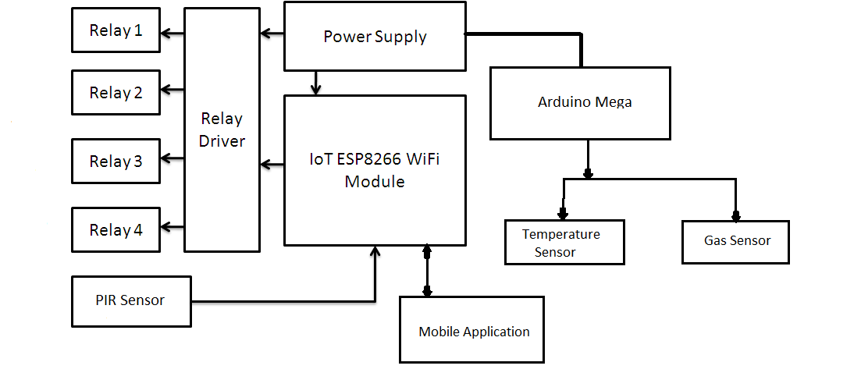

**FIG3.2:-BLOCK DIAGRAM**

**Description of block diagram:-**

1. Mobile application: Using this (**blynk**) application we can control the switches accordingly.

2. Nodemcu (**Esp 8266**): The command from mobile application or Google assistant (through blynk cloud ) is being processed accordingly and this signal is transmitted to relay driver .

3. PIR sensor: It is connected with NodeMCU .If there is any deviation found across the PIR sensor then the alert is send to the user in the mobile application through blynk cloud.

4. Relay Driver: It acts like a switch. It receives input from NodeMCU to respective relays (like relay 1, relay 2). The loads (like fan, lights etc) are connected to the relay1, relay2, relay3, relay4 accordingly. So if relay is turn on then the load will be activated and vice versa.

5. Power Supply: A single external power supply is connected to relay driver (5v),nodemcu(3.3 v)and arduino mega (5v)

6. Arduino mega: It’s a microcontroller which is connected to gas sensor (MQ6) and temperature sensor (themistor).

**Aim of our project:**

The aim of this project is to design and implement home automation on the basis of voice recognition. The user can control almost all the electronic appliances simply with the help of their voice commands and through the app. The project is implemented in hardware and software components that interact through **WIFI** (wireless fidelity) connections. The main challenge is to implement the project in an economical way such that it can be deployed and used in bigger decorative home appliances. An **ESP8266 WIFI** module, relay and a mobile phone with an Android platform running on top of it are the hardware and software used along with some sensors (MQ6, PIR) to make secured home automation.

**Two main characteristics of home automation:**

* Automation:

Automation refers to the ability to program and schedule events for the devices on the network. The programming may include time-related commands, such as having your lights turn on or off at specific times each day. It can also include non-scheduled events, such as turning on all the lights in your home when your security system alarm is triggered. Once you start to understand the possibilities of home automation scheduling, you can come up with any number of useful and creative solutions to make your life better.

* Remote control:

The other main characteristic of cutting-edge home automation is remote monitoring and access. While a limited amount of one-way remote monitoring has been possible for some time, it’s only since the rise in smart phones and tablets that we’ve had the ability to truly connect to our home networks while we’re away. With the right home automation system, you can use any Internet-connected device to view and control the system itself and any attached devices. Monitoring apps can provide a wealth of information about your home, from the status of the current moment to a detailed history of what has happened up to now. You can check your security system’s status, whether the lights are on, whether the doors are locked, what the current temperature of your home is and much more. With cameras as part of your home automation system, you can even pull up real-time video feeds and literally see what’s going on in your home while you’re away.

**Advantages of home automation:**

* Energy Efficiency:

One clear advantage of home automation is the unmatched potential for energy savings, and therefore cost savings. Your thermostat is already “smart” in the sense that it uses a temperature threshold to govern the home’s heating and cooling system. In most cases, thermostats can also be programmed with different target temperatures in order to keep energy usage at a minimum during the hours when you’re least likely to benefit from the heating and cooling. At the most basic level, home automation extends that scheduled programmability to lighting, so that you can suit your energy usage to your usual daily schedule. With more flexible home automation systems, electrical outlets or even individual devices can also be automatically powered down during hours of the day when they’re not needed. As with isolated devices like thermostats and sprinkler systems, the scheduling can be further broken down to distinguish between weekends and even seasons of the year, in some cases.

* **Savings:**

Smart thermostats and smart light bulbs save energy, cutting utility costs over time. Some home automation technologies monitor water usage, too, helping to prevent exorbitant water bills. Certain devices even offer rebates.

* **Safety:**

Many home automation technologies fall under the umbrella of home security. Consumers purchase these devices because they want to make their homes safer and more secure. Automated lighting thwarts would-be burglars, and motion sensors help people enter doors and walk hallways late at night Security cameras offer benefits through either remote monitoring of package deliveries or real-time video of home inhabitants or unwanted visitors.

* **Convenience:**

Because home automation technology performs rote tasks automatically, end users experience great convenience. Lots of smart gadgets are compatible with one another, and you can set different triggers between devices to automate regular home processes. For instance, you could set your smart locks to turn on your smart lighting when you unlock the front door.

* **Control:**

Consumers also choose smart home devices to better control functions within the home. With home automation technology, you can know what’s happening inside your home at all times.

* **Comfort:**

Some people use smart technology to record shows or to play music throughout the home. Connected devices can also help create a comfortable atmosphere—they provide intelligent and adaptive lighting, sound, and temperature, which can all help create an inviting environment.

* **Peace of Mind:**

Finally, many consumers invest in home automation technology for peace of mind. A new mom or dad can check on their little one thanks to smart cameras and other technologies. Or, if you can’t remember whether you closed the garage after you left, you can verify remotely with an app

.

* **User Friendly:**

We are all busy and home automation may be able to help make things a bit easier for us through which we can save both time and money.

**Disadvantages of home automation:**

* **Installation**:

Depending on the complexity of the system, installing a home automation device can be a significant burden on the homeowner. It can either cost you money if you hire an outside contractor or cost you time if you venture to do it yourself.

* **Complex Technology:**

Automating everything in life may sound extremely appealing, but sometimes a good old-fashioned flip of the switch is a lot easier than reaching for your smart phone to turn lights on and off. Before you decide which system is right for you, think about how far you really want to take home automation in your household.

* **System Compatibility:**

Controlling all aspects of home automation from one centralized platform is important, but not all systems are compatible with one another. Your security system, for example, may require you to log in to one location to manage settings, while your smart thermostat may require you to log in to another platform to turn the air conditioner on and off. To truly leverage the convenience of home automation, you may need to invest in centralized platform technology to control all systems and devices from one location.

* **Cost:**

Even though the price of home automation systems has become much more affordable in recent years, the cost to purchase and install a device can still add up. Consumer Reports offers a wide range of information and insights – including costs – on the best home automation systems on the market.

**OBJECTIVES OF OUR PROJECT**

Home automation system is a means that allow user to control electric appliances of various kinds. Many existing well established home automation systems are based on wired communication. This does not pose a problem until this system is planned well in advance and installed during the physical construction of a building. But for already existing buildings, the implementation costs go very high. In contrast wireless system can be great help for technologies such as **Wi-Fi**, **Cloud Networks** which are wireless systems and are used every day everywhere. The range of implementation of home automation is gigantic but for the time being we are trying to accomplish the following things:

* Suppose in your absence a fire has broken out in your house. It would have been easier if you had the knowledge about this event before you reached home only to find the debris. This can happen with the installation of home automation. A temperature sensor (thermistor 10k) is needed to be placed within your house which will constantly keep a check on the temperature. Any uncanny behavior in the temperature would be noted by the sensor and accordingly the circuit would function- a buzzer might go off to alarm the people nearby and the respective doors would fling open making way for the people to get out of the house.
* In case of any gas leak home automation may come handy. A gas leak is a result of human negligence. This human error can be taken care of by mounting a gas sensor (MQ6 Smoke & Flammable gas sensor) in your house. MQ2 Gas Sensor is sensitive to flammable/combustible gasses like LPG, Propane & Hydrogen. As soon as it detects a gas leak, a buzzer will go off and the windows will be flung open automatically.
* In your absence, in case of a burglary in your household, you can be instantly notified about the event with the help of home automation. This needs the installation of PIR sensors which detect any movement at a particular place. As soon as it detects, a message would be sent in your cell phone and accordingly you can take an action. This will mark a new dawn in security.

**COMPONENTS REQUIRED**

* **Blynk :**

**Blynk is an app which works over the Internet t**his means that the hardware you choose should be able to connect to the internet. Some of the boards, like Arduino Uno will need an Ethernet or Wi-Fi Shield to communicate, others are already Internet-enabled: like the ESP8266, Raspberry Pi with WIFI dongle, Particle Photon or SparkFun Blynk Board. But even if you don’t have a shield, you can connect it over USB to your laptop or desktop.

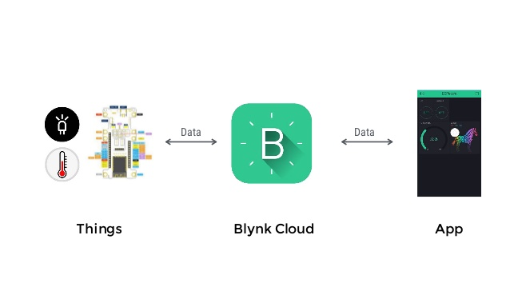

**Fig 2.1:-BLYNK**

* **Cloud Storage:**

IaaS (Infrastructure as a Service or Utility Computing) follows a traditional utilities model, providing servers and storage on demand with the consumer paying accordingly. PaaS (Platform as a Service) allows for the construction of applications within a provider’s framework, like Google’s App Engine. SaaS enables customers to use an application on demand via a browser. A common example of cloud computing is Gmail, where you can access your stored data from any computer with internet access.

* **Google Assistant:**

The **Google Assistant** is an artificial intelligence-powered virtual assistant developed by Google that is primarily available on mobile and smart home devices. Unlike the company's previous virtual assistant, Google Now, the Google Assistant can engage in two-way conversations.

Users primarily interact with the Google Assistant through natural voice, though keyboard input is also supported. In the same nature and manner as Google Now, the Assistant is able to search the Internet, schedule events and alarms, adjust hardware settings on the user's device, and show information from the user's Google account. Google has also announced that the Assistant will be able to identify objects and gather visual information through the device's camera, and support purchasing products and sending money, as well as identifying songs.

* **NodeMCU** **:**

It is an open source IoT platform. It includes firmware which runs on the **ESP8266** Wi-Fi SoC from Espressif Systems and hardware which is based on the **ESP-12** module. The term "**NodeMCU**" by default refers to the firmware rather than the development kits. The firmware uses the Lua scripting language. It is based on the eLua project, and built on the Espressif Non-OS SDK for **ESP8266**. It uses many open source projects, such as lua-cjson and spiffs.

* **Arduino Mega:**

The**Arduino Mega 2560** is a microcontroller board based on the ATmega2560. It has 54 digital input/output pins (of which 15 can be used as PWM outputs), 16 analog inputs, 4 UARTs (hardware serial ports), a 16 MHz crystal oscillator, a USB connection, a power jack, an ICSP header, and a reset button. It contains everything needed to support the microcontroller; simply connect it to a computer with a USB cable or power it with a AC-to-DC adapter or battery to get started. The Mega 2560 board is compatible with most shields designed for the Uno and the former boards Duemilanove or Diecimila.

* **Relay:**

This is a 5V 4-channel relay interface board, and each channel needs a 15-20mA driver current. It can be used to control various appliances and equipment with large current. It is equipped with high-current relays that work under AC250V 10A or DC30V 10A. It has a standard interface that can be controlled directly by microcontroller.

* **Servo Motor:**

A servo motor is a closed-loop system that uses position feedback to control its motion and final position. In industrial type servo motors the position feedback sensor is usually a high precision encoder, while in the smaller RC or hobby servos the position sensor is usually a simple potentiometer.

* **PIR Motion Sensor:**

This is a highly integrated module popularly used for entry detection, it can be easily adopted in any system. Power it up and wait 1-2 seconds for the sensor to get a snapshot of the still room. If anything moves after that period, the 'alarm' pin will go low. This sensor checks for infrared heat in it's detecting angle. Human body, pets and several other things emit energy that the sensor is looking for, it compares with the snapshot and if there is a recent change it triggers.

* **Gas sensor:**

This is a very easy to use low cost semiconductor Gas sensor Module with analog and digital output. This module uses MQ6 Smoke & Flammable gas sensor as a gas sensing element. It requires no external components just plug in Vcc & ground pins and you are ready to go.For Digital output the threshold value can be easily set by an on-board potentiometer.  Using this module you can easily interface MQ2 Smoke & Combustible gas Sensor to any Microcontroller, Arduino or even Raspberry Pi. Since this Gas Sensor module is sensitive to smoke it can be used in for fire detection. MQ2 Gas Sensor is also sensitive to flammable/combustible gasses like LPG, Propane & Hydrogen.

* **12 Volt DC Fan:**



**FIG2.2:- 12V DC FAN**

Bgears b-Blaster 80mm 2 ball bearing high performance fan. Extreme Speed at 3500 RPM with Excellent Airflow of up to 62 CFM. 3 pin 3 wires connector with fan speed signal output. Include a 3 to 4 pin Molex adapter for direct connection to Power Supply. 4 screws included.

* **Night Bulb:**

A 0.5 watt LED bulb is used.

* **Buzzer**
* **9 Volt Battery**
* **Connecting Wires**

**CHAPTER 3**

**FLOW CHART:-**

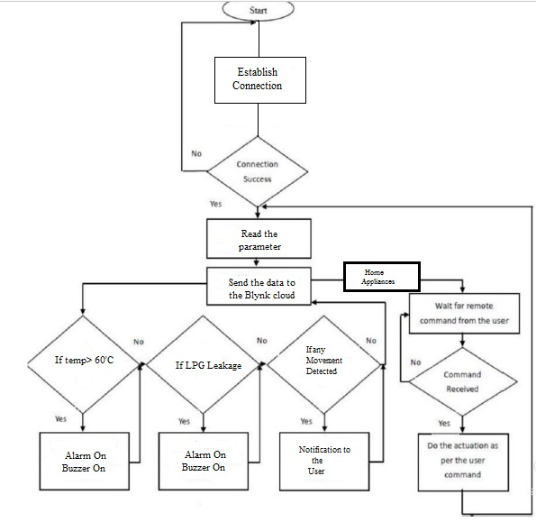

**FIG3.1:-FLOW CHART**

**Description of flowchart:-**

The whole system can be remotely controlled just with the help of a mobile application. When a command is to be generated, the connection between the user and the NodeMCU is made with the help of Blynk. If the connection is successfully made, the module will read the parameters to understand what actions to be taken care of. This whole process is being done by fetching the necessary data from the Blynk cloud.

If the parameters are related to sensor part, it will read certain readings, if anything is not satisfactory, the alarm will be on. On the other hand, if the user wants to control the home appliances, he/she can send the right commands through Blynk. If the command is valid, the system will work accordingly like switching on/off lights and fans. There is another advantage of the sensor implementation, for example, if the fire breaks out, the front door will open so that anyone elderly or children can go out of the home safely and call for help. In case of gas leakage, the windows will open, to bypass the gas so that it does not become suffocating inside

**CIRCUIT DIAGRAM:-**

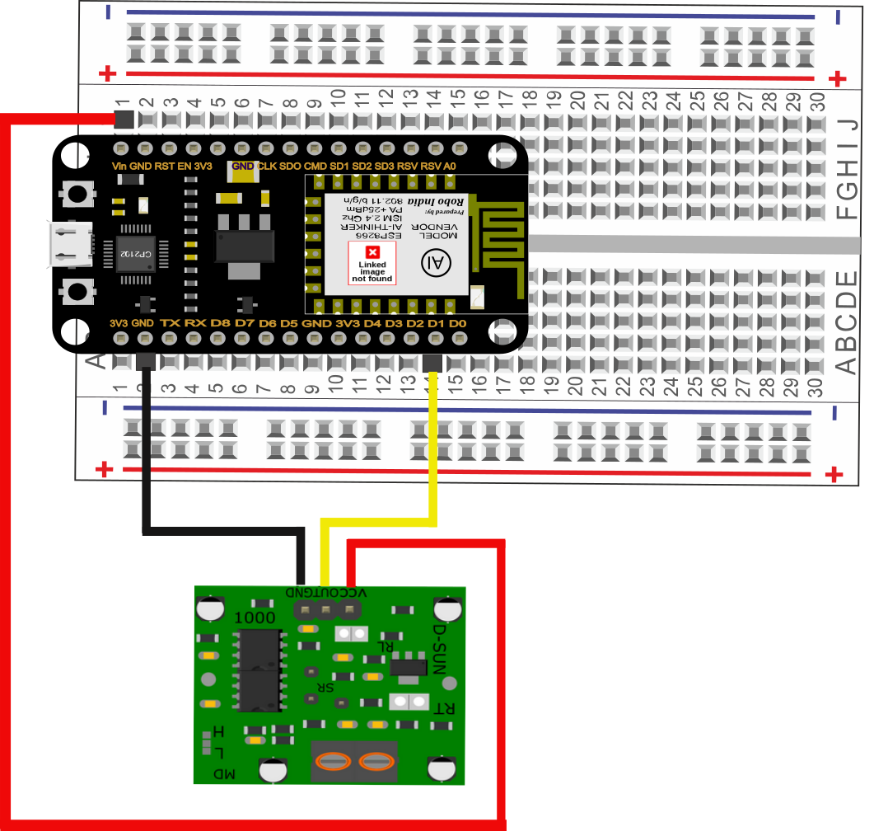

**FIG 3.3:-CIRCUIT DIAGRAM 1 (FOR PIR SENSOR)**

Explanation:-

1. PIR sensor has three pins Vcc ,Gnd , Output pin
2. The Gnd pin of Nodemcu is connected to the Gnd pin of the PIR sensor the Vin pin of Node mcu is connected to the Vcc pin of the PIR sensor and the data pin (D1) is connected to the output pin of the PIR sensor.
3. Now when we find the LED blinking whenever there is any motion across the PIR senor and thus we receives a notification through blynk app.

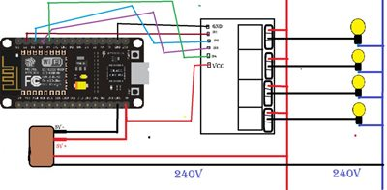

**FIG3.4Circuit diagram 2**

Explanation:

1. The pins (D0,D2,D3) are connected to the relay pins (INC1,INC2INC3)respectively
2. A usb cable is used to give power supply to the node mcu
3. Arduino mega is used to give a +5v power supply to relay
4. The +Vcc and Gnd pins of relay is connected to the Vcc and Gnd of relay
5. The loads are connected to the output pins of relay as shown in circuit diagram above

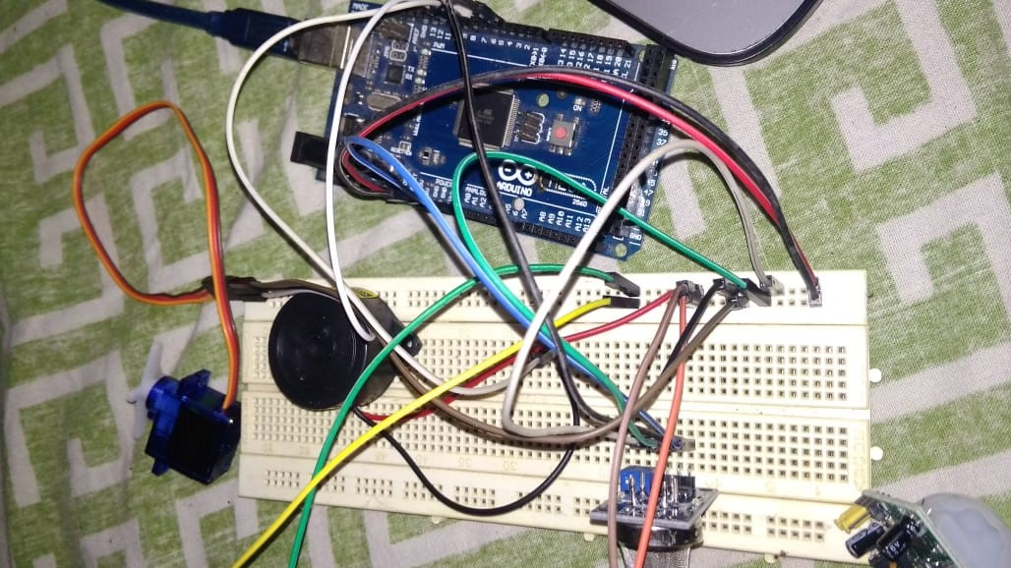

**FIG3.5:-Circuit Diagram 3**

1. We have connected the gas sensor MQ6 to a buzzer and to a servo motor with the help of arduino mega
2. The +Vcc and Gnd of arduino is connected to Vcc and Gnd of MQ6 gas sensor and the output pin of Gas sensor is connected to the pin 4 of arduino mega

3. Similarly the +Vcc and Gnd pins of ardiuno are connected the Vcc and the Gnd of Servo motor and the buzzer

4. Pin 8 of arduino mega is connected to the buzzer

**CHAPTER 4**

**RESULT ANALYSIS**

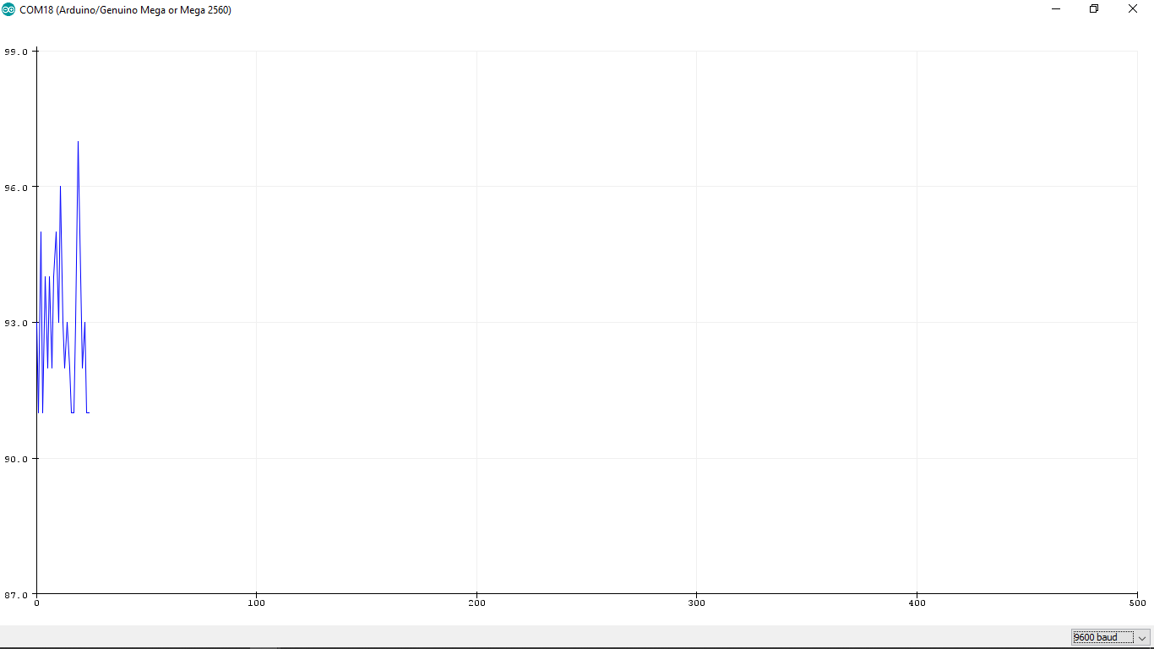

Fig4.1**:-** Snapshot ofGraph obtained for MQ6 gas sensor

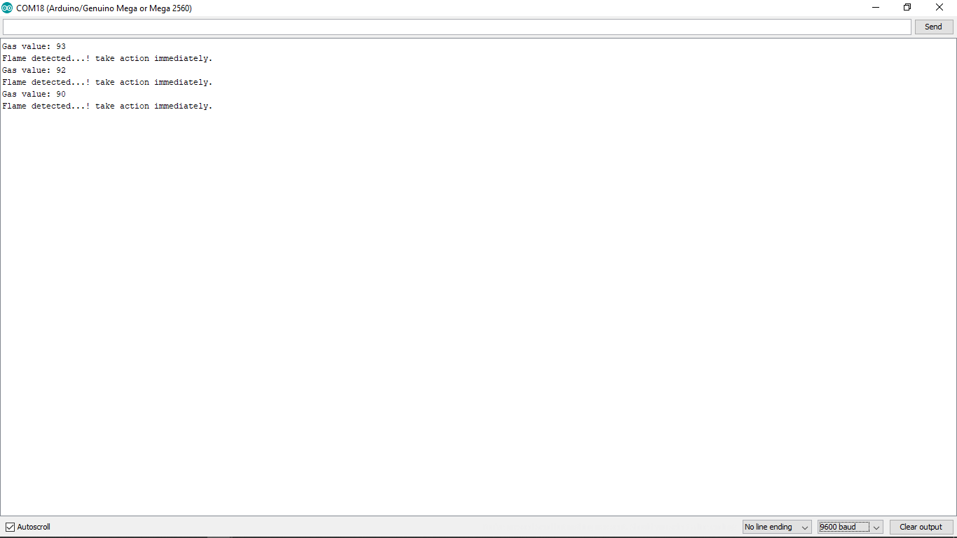

Fig4.2 :-Snapshot of readings and message obtained for MQ6 gas sensor



Fig 4.3:-Snapshot of Blynk app final widget setup

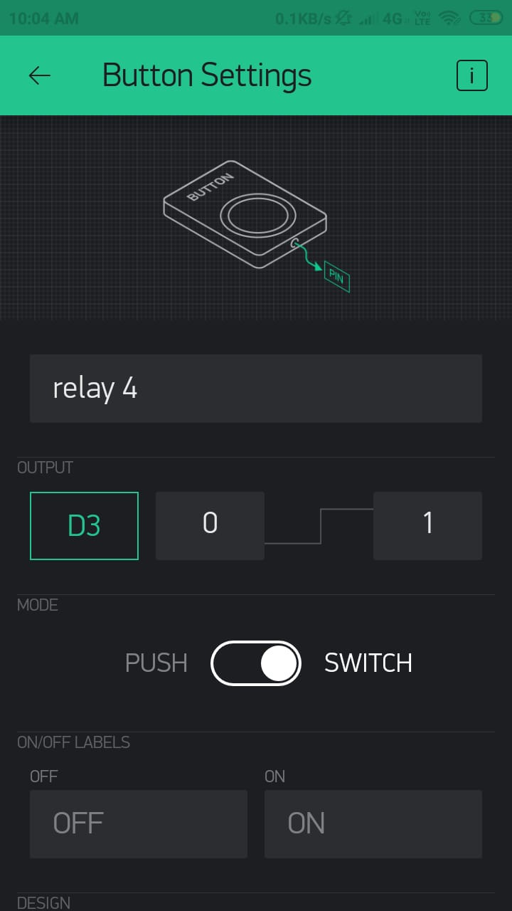

Fig 4.4- Snapshot of button settings

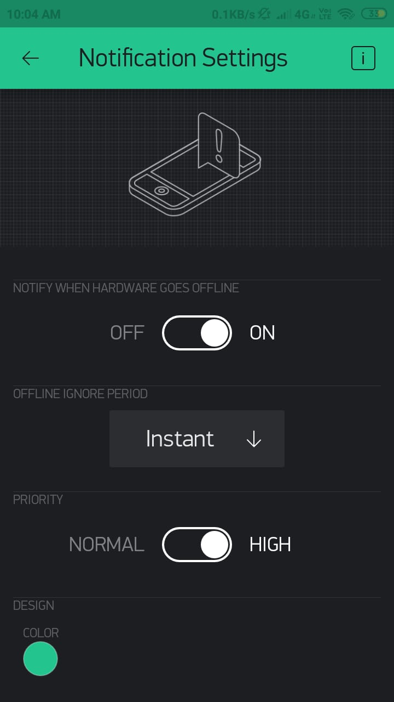

Fig4.5:-Snapshot of notifications settings used for MQ6 gas sensor

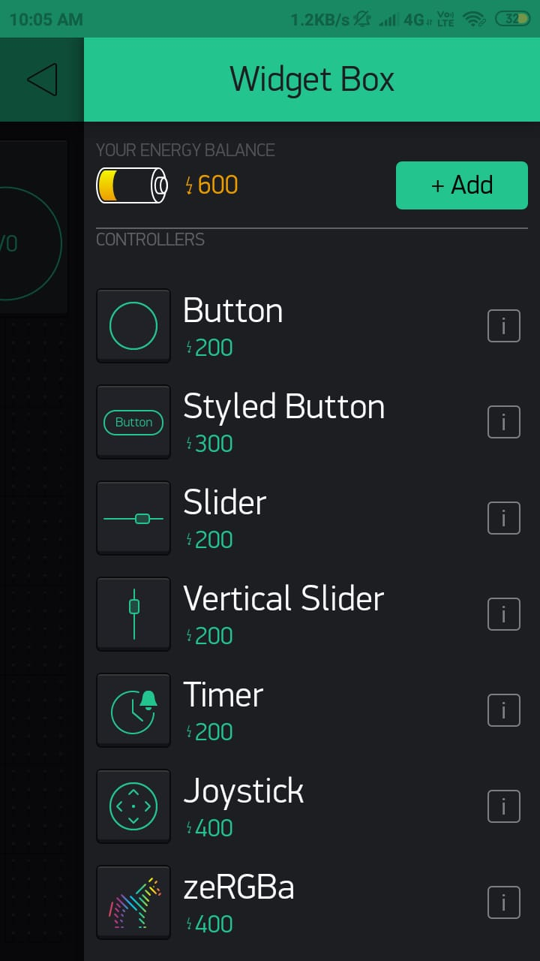

Fig4.6:- Snapshot of creation of widgets

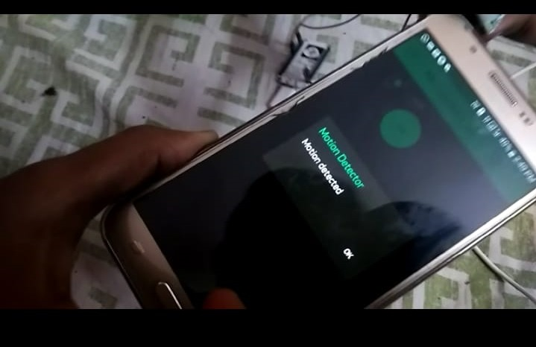

Fig4.7:-Snapshot of notification received on Blynk app

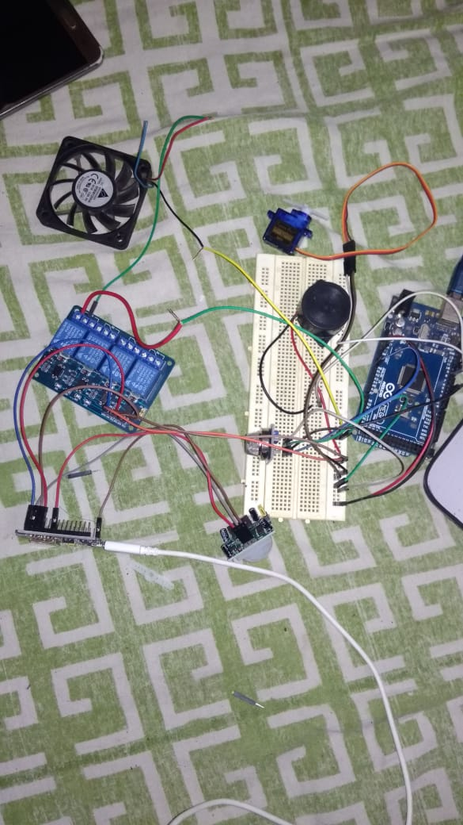

Fig4.8: Snapshot of the circuit

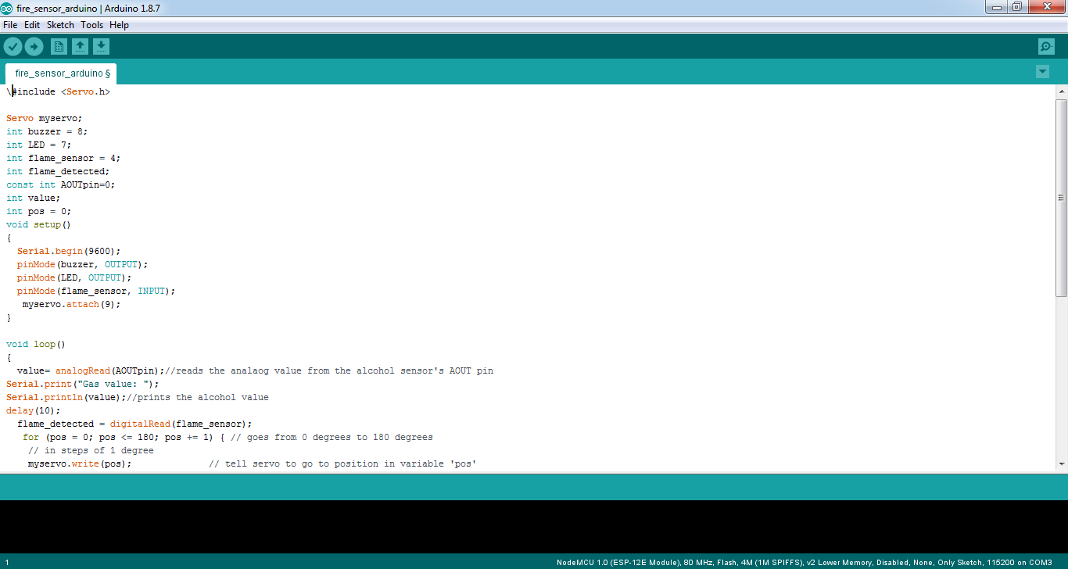

Fig4.9:-Snapshot of arduino coding

**CHAPTER 5**

**APPLICATIONS AND FUTURE SCOPE**

Any day-to-day, repeatable process is automatable with smart home applications. The greater the control and flexibility of these processes, the more energy and cost savings the resident experiences, which are factors anyone who pays utilities strives to moderate. The smart home revolution is likely to be more of an evolution, with the incorporation of one or two home systems at a time, gradually automating our households through smart mobile devices. Home automation offers a wide variety of implementation.

* [Lighting control system](https://en.wikipedia.org/wiki/Lighting_control_system):

Our project strives to switch on or off appliances through voice commands in our cell phones. We can take a step ahead by controlling the intensity of light or the speed of fan through our mobiles. Lighting Control System is a "smart" network that incorporates communication between various lighting system inputs and outputs, using one or more central computing devices.  Lighting control systems serve to provide the right amount of light where and when it is needed.Lighting control systems are employed to maximize the energy savings from the lighting system, satisfy building codes, or comply with green building and energy conservation programs. Lighting control systems are often referred to under the term Smart Lighting.

* Home automation for the elderly and disabled:

The form of home automation focuses on making it possible for older adults and people with disabilities to remain at home, safe and comfortable. Home automation is becoming a viable option for older adults and people with disabilities who would prefer to stay in the comfort of their homes rather than move to a healthcare facility. This field uses much of the same technology and equipment as home automation for security, entertainment, and energy conservation but tailors it towards older adults and people with disabilities. There are two basic forms of home automation systems for the elderly: *embedded health systems* and *private health networks*. Embedded health systems integrate sensors and microprocessors in appliances, furniture, and clothing which collect data that is analyzed and can be used to diagnose diseases and recognize risk patterns. Private health networks implement wireless technology to connect portable devices and store data in a household health database. Due to the need for more healthcare options for the aging population "there is a significant interest from industry and policy makers in developing these technologies".

* Air quality control:

For example, Air Quality Egg is used by people at home to monitor the air quality and pollution level in the city and create a pollution map. The Air Quality Egg (AQE) is an open source hardware Internet of Things platform and hobbyist device for crowd sourced citizen monitoring of airborne pollutants. Originally there were two versions of the device: an Arduino shield for use by hobbyists, and a more consumer-ready "hobbyist kit" device. The latter consists of two identical-looking plastic enclosures resembling white eggs. One unit, the base unit, is connected to the user's Ethernet LAN connection. The second unit monitors NO2 and CO levels and reports these readings every few minutes back to the base unit via a custom wireless protocol.

* Smart Kitchen and Connected Cooking:

Using Voice control devices like Google Home or mobile applications to manage coffee machines, ovens, fridge and multi cooker, as Instant Pot or robotic kitchen. Bringing together all of these appliances is home automation and technology. Whether it is an I Phone and automation or just to control a single appliance, all you need is a Smart Phone or tablet and a Wi-Fi connection to get started.

* Automatic door lock system:

This would be very useful if a child or an elderly person is unable to unlock the door. Just a touch on the mobile phone screen would be enough to serve the purpose.

The home automation system helps you control the devices at your home automatically. In order to change the settings of it you simple need to have a computer, android device with internet or remote control. In this way everything will work according to your wish. We have heard about smart phones and smart devices, by installing a home automation system you can very easily make your ordinary home a smart home.

**REFERENCES**

1. **Charith Perera**, Student Member, IEEE, Arkady Zaslavsky, Member, IEEE, “Context Aware Computing for The Internet of Things: A Survey”. IEEE COMMUNICATIONS SURVEYS & TUTORIAL
2. **Bill N. Schilit, Norman Adams**, and **Roy Want**, “Context-Aware Computing Applications”.
3. **Inderpreet Kaur**, “Microcontroller Based Home Automation System with Security” at IJACSA) International Journal of Advanced Computer Science and Applications. Vol.1 , No. 6, December 2010.
4. Paul Jasmin Rani(student member IEEE) ; Jason Bakthakumar Voice controlled home automation system using Natural Language Processing (NLP) and Internet of Things (IoT).
5. Abdul Aziz Md (lecturer, CSE dept RGUKT,APIIIT ), “cost effective voice control home automation using IOT”.
6. Design of an Intelligent Voice Controlled Home Automation System Sonali Sen, Shamik Chakrabarty, Ankita Bhaumik, Department of Computer Science, St. Xavier’s College, Kolkata
7. S.P. Pande, Prof. Pravin Sen, “Review On: Home Automation System For Disabled People Using BCI” in IOSR Journal of Computer Science (IOSR-JCE) e- ISSN: 2278-0661, p-ISSN: 2278-8727 PP 76-80.
8. Basil Hamed, “Design & Implementation of Smart House Control Using LabVIEW”.
9. Basma M. Mohammad El-Basioni1, “Smart HomeDesign using Wireless SensorNetwork and Biometric Technologies” at Volume 2, Issue 3, March 2013.
10. Jayavardhana Gubbi, ,Rajkumar Buyya, Slaven Marusic,a Marimuthu Palaniswamia, “Internet of Things (IoT): A Vision, Architectural Elements, and Future Directions”.

**ANNEXURE A**

**Details of program:-**

**1. Gas Sensor:**

#include <Servo.h>

Servo myservo;

int buzzer = 8;

int LED = 7;

int flame_sensor = 4;

int flame_detected;

const int AOUTpin=0;

int value;

int pos = 0;

void setup()

{

Serial.begin(9600);

pinMode(buzzer, OUTPUT);

pinMode(LED, OUTPUT);

pinMode(flame_sensor, INPUT);

myservo.attach(9);

}

void loop()

{

value= analogRead(AOUTpin);//reads the analaog value from the alcohol sensor's AOUT pin

Serial.print("Gas value: ");

Serial.println(value);//prints the alcohol value

delay(10);

flame_detected = digitalRead(flame_sensor);

for (pos = 0; pos <= 180; pos += 1) { // goes from 0 degrees to 180 degrees

// in steps of 1 degree

myservo.write(pos); // tell servo to go to position in variable 'pos'

delay(15); // waits 15ms for the servo to reach the position

}

if (flame_detected == 1)

{

Serial.println("Flame detected...! take action immediately.");

digitalWrite(buzzer, LOW);

digitalWrite(LED, HIGH);

delay(3000);

digitalWrite(LED, LOW);

}

else

{

Serial.println("No flame detected. stay cool");

digitalWrite(buzzer, HIGH);

digitalWrite(LED, LOW);

}

for (pos = 180; pos >= 0; pos -= 1) { // goes from 180 degrees to 0 degrees

myservo.write(pos); // tell servo to go to position in variable 'pos'

delay(15); // waits 15ms for the servo to reach the position

}

delay(100);

}

**2. NodeMCU with relay:**

#define BLYNK_PRINT Serial

#include <ESP8266WiFi.h>

#include <BlynkSimpleEsp8266.h>

char auth[] = " 09230e74d8414d1d85da21770586f214";

// Your WiFi credentials.

// Set password to "" for open networks.

char ssid[] = "roy";

char pass[] = "happynewyear";

void setup()

{

// Debug console

Serial.begin(9600);

Blynk.begin(auth, ssid, pass);

void loop()

{

Blynk.run();

}

**3. PIR sensor with NodeMCU:**

#include <ESP8266WiFi.h>

#define BLYNK_PRINT Serial

#include <BlynkSimpleEsp8266.h>

char auth[] = " 09230e74d8414d1d85da21770586f214";

/* WiFi credentials */

char ssid[] = "roy";

char pass[] = "happynewyear";

#define pirPin 5 // Input for HC-S501

int pirValue; // Place to store read PIR Value

int pinValue;

BLYNK_WRITE(V0)

{

pinValue = param.asInt();

}

void setup()

{

Serial.begin(115200);

delay(10);

Blynk.begin(auth, ssid, pass);

pinMode(pirPin, INPUT);

}

void loop()

{

if (pinValue == HIGH)

{

getPirValue();

}

Blynk.run();

}

void getPirValue(void) //Get PIR Data

{

pirValue = digitalRead(pirPin);

if (pirValue)

{

Serial.println("Motion detected");

Blynk.notify("Motion detected");

}

}

**4. Temperature sensor with Arduino:**

#include <SoftwareSerial.h>

#include<LiquidCrystal.h>

LiquidCrystal lcd(12, 11, 5, 4, 3, 2);

SoftwareSerial SIM900(9,10); //receive-9,transmit-10 of arduino

int sensor=A1;

int buzzer=7;

int led=8;

float temp,alert_val,shut_val;

int Fire_Set;

void setup()

{

pinMode(sensor,INPUT);

pinMode(buzzer,OUTPUT);

pinMode(led,OUTPUT);

SIM900.begin(2400);

Serial.begin(4800);

lcd.begin(16,2);

delay(500);

}

void loop()

{

CheckFire();

CheckShutDown();

}

void CheckFire()

{

lcd.setCursor(2,0);

lcd.print("Scan on");

alert_val=CheckTemp();

if(alert_val>40)

{

Fire_Set=1;

lcd.setCursor(0,1);

lcd.print("hi temp!!");

delay(500);

digitalWrite(led,HIGH);

delay(500);

digitalWrite(buzzer,HIGH);

delay(2000);

delay(100);

SIM900.println();

delay(20000); //wait for 30 sec

SIM900.println("ATH"); //disconnect after 30 sec

Serial.println("ATH");

}

}

float CheckTemp()

{

temp=analogRead(sensor);

temp=temp*5;

temp=temp/10;

return temp;

}

void CheckShutDown()

{

if(Fire_Set==1)

{

shut_val=CheckTemp();

if(shut_val<40)

{

lcd.setCursor(0,1);

lcd.print("no issues !!");

delay(500);

digitalWrite(led,LOW);

delay(500);

digitalWrite(buzzer,LOW);

delay(500);

Fire_Set=0;

}

}

}

**ANNEXURE C**

**NodeMCU:**

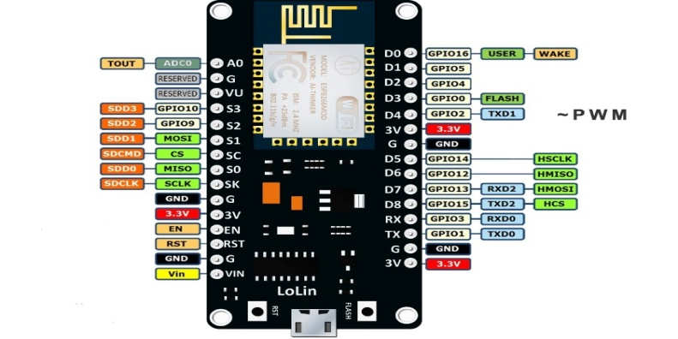

**FIG5.1:-NODE MCU**

### Digital I/O

The ESP8266 has digital input/output pins (I/O or GPIO, General Purpose Input/Output pins). As the name implies, they can be used as digital inputs to read a digital voltage, or as digital outputs to output either 0V (sink current) or 3.3V (source current).

**Usable Pins**

The ESP8266 has 17 GPIO pins (0-16), however, you can only use 11 of them, because 6 pins (GPIO 6 - 11) are used to connect the flash memory chip. This is the small 8-legged chip right next to the ESP8266.

**Boot Modes**

| **GPIO15** | **GPIO0** | **GPIO2** | **Mode** |
| --- | --- | --- | --- |
| 0V | 0V | 3.3V | Uart Boot loader |
| 0V | 3.3V | 3.3V | Boot sketch (SPI flash) |
| 3.3V | X | X | SDIO mode (not used for Arduino) |

Some I/O pins have a special function during boot: They select 1 of 3 boot modes:

.

**RELAY:**

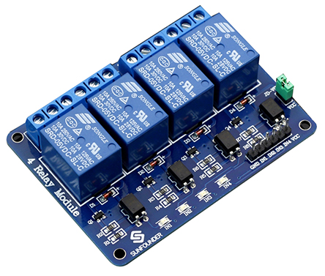

**FIG 5.2:-RELAY**

**Input:**

VCC: Connected to positive supply voltage (supply power according to relay voltage).

GND: Connected to supply ground.

IN1: Signal triggering terminal 1 of relay module

IN2: Signal triggering terminal 2 of relay module IN

IN3: Signal triggering terminal 3 of relay module

IN4: Signal triggering terminal 4 of relay module

Output: Each module of the relay has one NC(normally close) one NO(normally open) and one COM(Common) terminal.

So there are 4NC, 4 NO and 4 COM of the channel relay in total

**ARDUINO:**

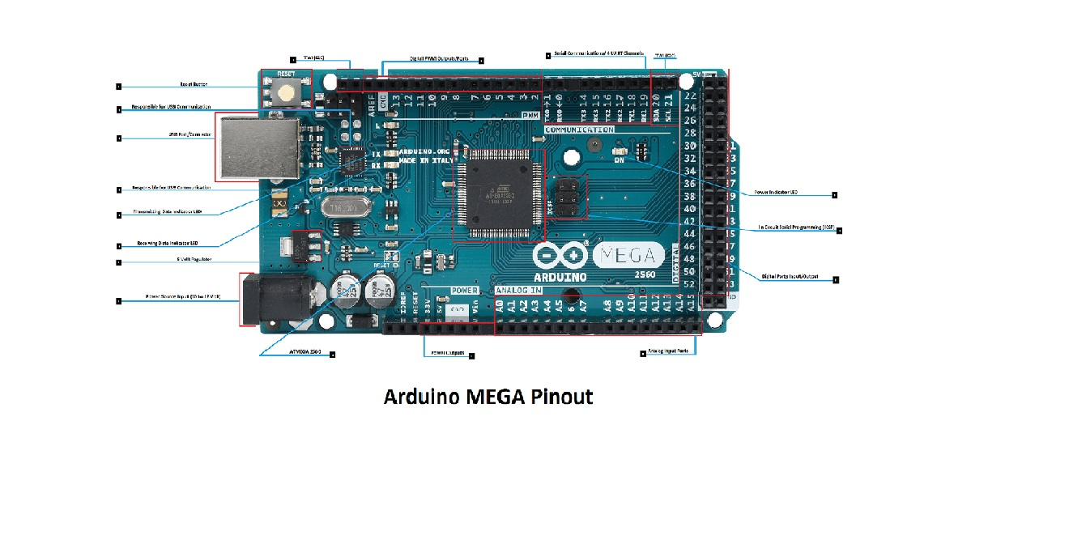

**FIG5.3:-ARDUINO MEGA**

**Technical Specialization**

Microcontroller ATmega2560

Operating Voltage 5V

Input Voltage (recommended) 7-12V

Input Voltage (limits) 6-20V

Digital I/O Pins 54 (of which 14 provide PWM output)

Analog Input Pins 16

DC Current per I/O Pin 40 mA

DC Current for 3.3V Pin 50 mA

Flash Memory 256 KB of which 8 KB used by bootloader

SRAM 8 KB

EEPROM 4 KB

Clock Speed 16 MHz

**Proximity Infrared Sensor(PIR):**

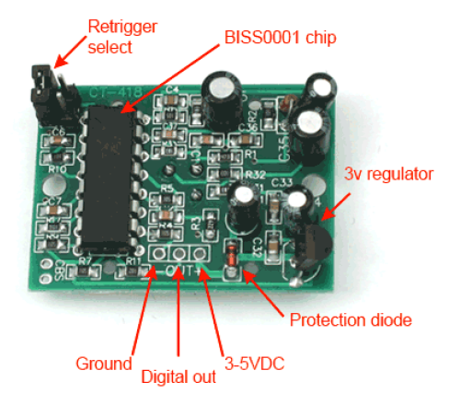

**FIG 5.4:-PIR SENSOR**

Quantity- 1

Pulse lengths are determined by resistors and capacitors on the PCB and differ from sensor to sensor. Sensitivity range: up to 20 feet (6 meters) 110° x 70° detection range .

**Pin Configuration**:-

|  |  |  |
| --- | --- | --- |
| PIN NUMBER | PIN NAME | DESCRIPTION |
| 1 | Vcc | Input voltage is +5V for typical applications. Can range from 4.5V- 12V |
| 2 | High/Low Output (Dout) | Digital pulse high (3.3V) when triggered (motion detected) digital low(0V) when idle(no motion detected |
| 3 | Ground | Digital pulse high (3.3V) when triggered (motion detected) digital low(0V) when idle(no motion detected |

**Gas Sensor(MQ6):**

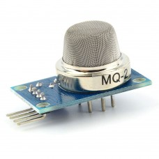

**FIG 5.5:-GAS SENSOR**

Quantity: 1

**Specification:**

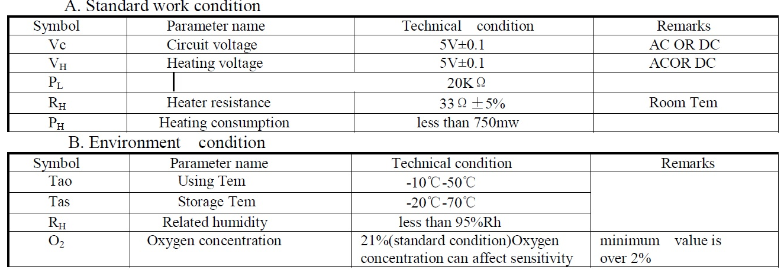

**Thermistor:**

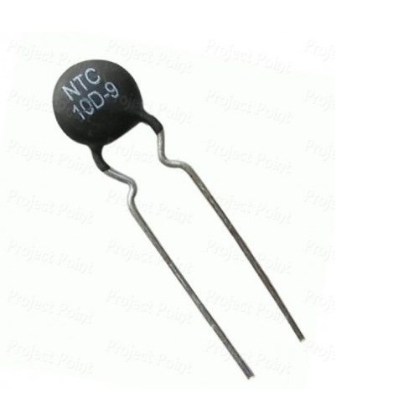

**FIG5.6:-THERMISTOR**

Quantity: 1

Thermistors are manufactured to follow a specific curve with a high degree of accuracy. All thermisters have a standard accuracy of ± 0.2 °C throughout the commercial temperature range of 0 to 70 °C.

**Technical Specifications**:

Resistance at 25 degrees C: 10K +- 1%

B-value (material constant) = 3950+- 1%

Dissipation factor (loss-rate of energy of a mode of oscillation) δ th = (in air)approx.7.5mW/K

Thermal cooling time constant <= (in air) 20 seconds